**Test Case 0004**

**System:** Bench

**Description:** Test that the social media is correctly linked and redirects to the page correctly.

**Severity:** 3

**Instructions**

**Test1**

1. Start the Bench application.
2. Click the button “Login” on the navigation bar.
3. Enter the email “team23project@gmail.com” into the text field labeled “Email address”.
4. Enter the password “12345678” into the field labeled “Password”.
5. Click the button “Login” below the field.
6. After the screen has loaded, three panels of different users’ profiles should appear.
7. Click on the button labeled “View Profile” of any of the user panels displayed.
8. The current user should be directed to the detailed profile page of the selected user.

**Expected Result:** The social media links of the selected user should be displayed on their profile page.

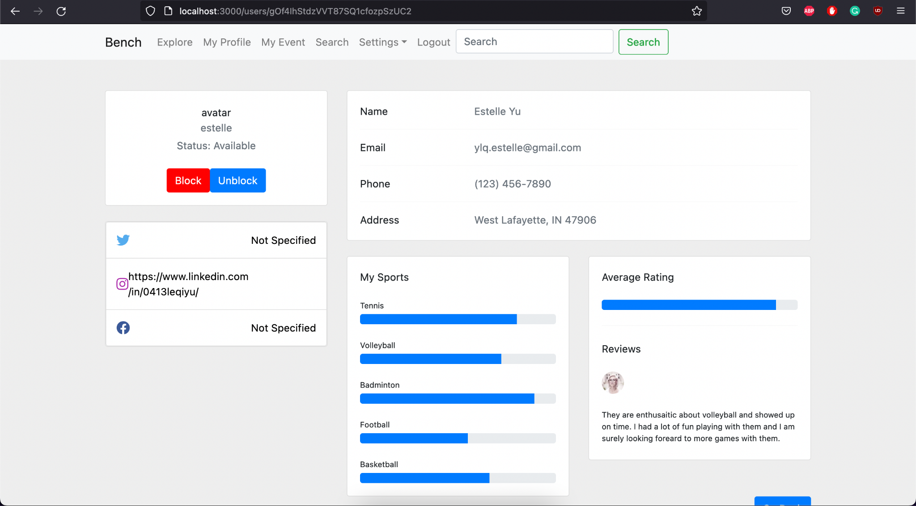

**Test2**

1. Start the Bench application.
2. Click the button “Login” on the navigation bar.
3. Enter the email “team23project@gmail.com” into the text field labeled “Email address”.
4. Enter the password “12345678” into the field labeled “Password”.
5. Click the button “Login” below the field.
6. After the screen has loaded, three panels of different users’ profiles should appear.
7. Click on the button labeled “View Profile” of any of the user panels displayed.
8. The current user should be directed to the detailed profile page of the selected user. The social media links of the selected user should be displayed on it.
9. Observe the icons beside those social media links.

**Expected Result:** users should be able to distinguish between social media platforms via icons beside each link.



**Test 3**

1. Start the Bench application.
2. Click the button “Login” on the navigation bar.
3. Enter the email “team23project@gmail.com” into the text field labeled “Email address”.
4. Enter the password “12345678” into the field labeled “Password”.
5. Click the button “Login” below the field.
6. After the screen has loaded, three panels of different users’ profiles should appear.
7. Click on the button labeled “View Profile” of any of the user panels displayed.
8. The current user should be directed to the detailed profile page of the selected user. The social media links with their platform icons of the selected user should be displayed on it.
9. Click on any of those social media links.

**Expected Result:** the user should be redirected to the social media web page of the selected social media platform.



